NFHS Sportsmanship Directions

1. Go to ahsaa.com. Click on School/Parent Resources, NFHS Sportsmanship, NFHS Sportsmanship Course (Students & Coaches). This will take you to the NFHS website.

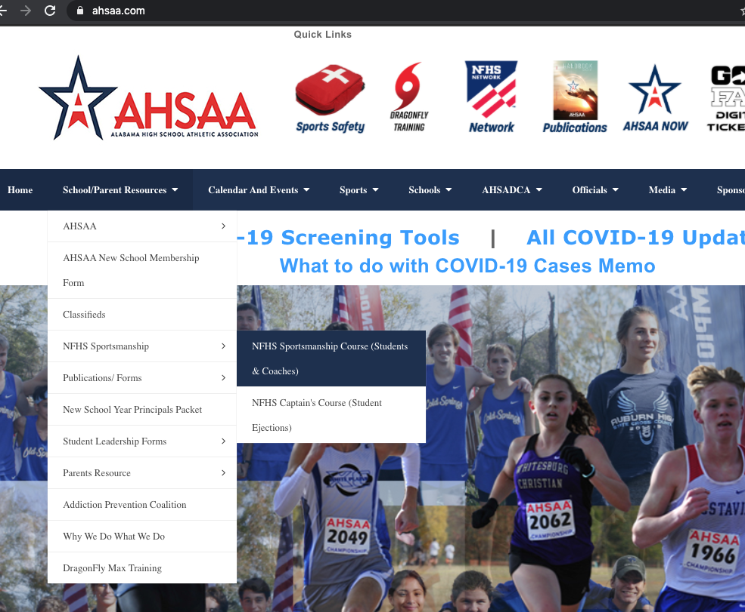

1. On the NFHS site, click select state, choose Alabama, then click Order Course (free). You will then need to Register. Please use an email and password that you will remember.

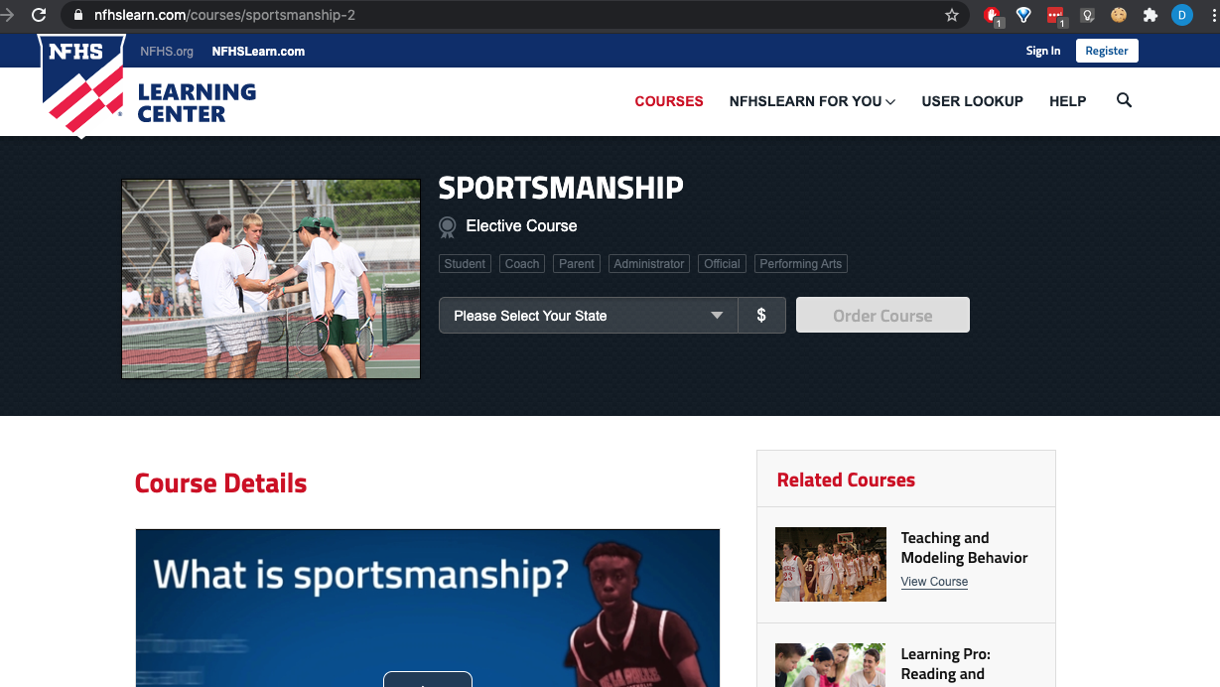

1. You will be asked who is taking this course, choose myself. You will also go through a checkout process like you are buying something. Be sure Alabama shows as your State. Click Checkout.

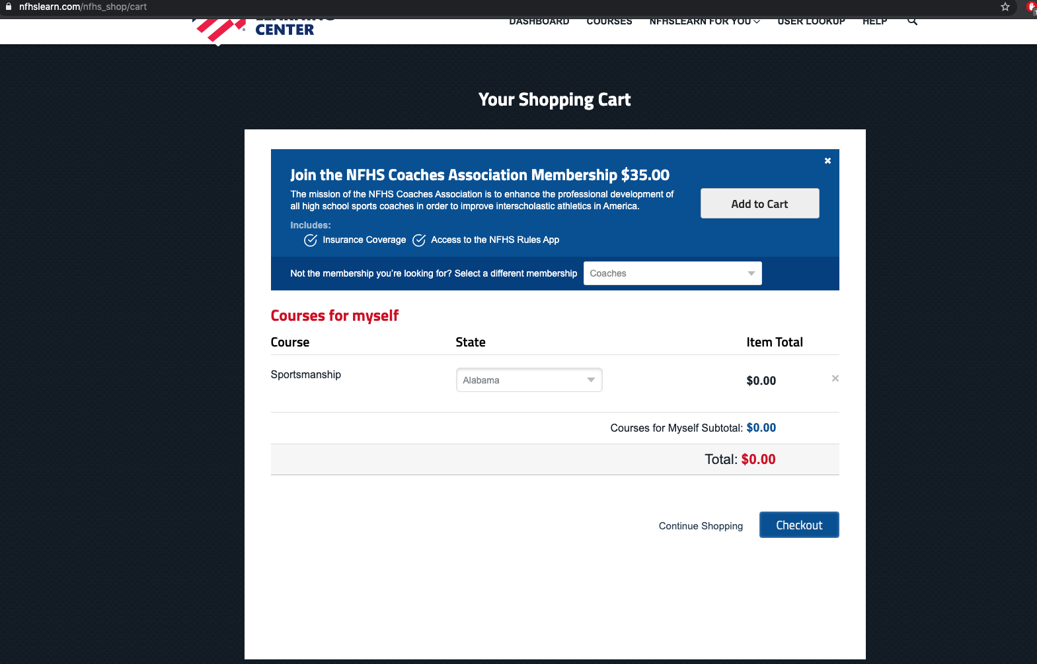

1. Agree to the statement, click continue.